Over 60 Virtual Tours and Trips
Aquariums
Baltimore National Aquarium |   Baltimore National Aquarium has a selection of Live Cams (Blacktip Reef, Jellies Invasion and Pacific Coral Reef) and also offers a floor-by-floor, interactive Virtual Tour.
Clearwater Marine Aquarium |   Watch live cams of their rescued dolphins, Winter, Hope and PJ, as well as an otter, pelican and turtle camera.
Georgia Aquarium |   Find live cams for Jellyfish, Beluga Whales, Piranhas, California Sea Lions, African Penguins, Southern Sea Otters, the Indo-Pacific Barrier Reef, an underwater Puffin cam and the Ocean Voyager cam.
Monterey Bay Aquarium |   Be delighted by the antics of their sea otters or mellow out to the hypnotic drifting of their jellies. With ten live cams to choose from, you can experience the wonder of the ocean no matter where you are.
Art Galleries and Museums
Georgia O’Keeffe Museum |   Six virtual exhibits are available online from this museum named for the "Mother of American modernism."
High Museum of Art, Atlanta |   (More suitable for Years 5 and 6, due to the theme)  "Civil Rights Photography" — photos that capture moments of social protest like the Freedom Rides and Rosa Park's arrest.
National Gallery, London | 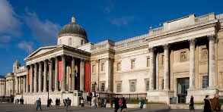  Get a dose of art and culture thanks to the virtual tour on offer from the National Gallery in London. Tour the rooms and wings and zoom in on the artwork to see some of the highlights.
Solomon R. Guggenheim Museum | 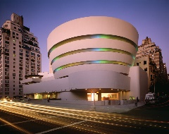  The works of Pablo Picasso, Piet Mondrian, Jeff Koons, and Franz Marc are just some of the 625 artists whose work are a part of the Guggenheim's Collection Online.
Tate Art Galleries | 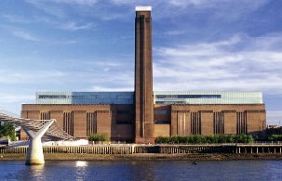  View and find out about over 70,000 works of art from the various Tate Art Galleries around the UK.  There is also a Tate website dedicated to children where they can explore, make or take part in games and quizzes.
The Louvre |   Travel to Paris, France to see amazing works of art at The Louvre with this virtual trip.  Click here for a more general view of the building.
Thyssen-Bornemisza Museum |   Madrid's must-see art museum has the works of some of the continent's most celebrated artists like Rembrandt and Dali available online.
Van Gogh Museum |   At the Van Gogh Museum in Amsterdam, Netherlands, you can get up close and personal with the impressionist painter's most famous work.
Famous Places, Landmarks and Buildings
Angkor Wat |   Travel to Angkor Wat in Cambodia through 3D simulations of temples and 360º videos.
The Acropolis | 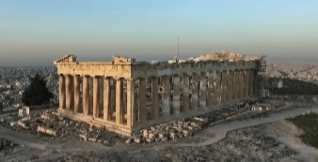  Visit the ancient citadel of Athens, Greece: The Acropolis, with a virtual tour offering 360º views and explanations of some of the fascinating history.
Barcelona’s Camp Nou Stadium |   Barcelona’s Camp Nou Stadium: visit the entrance, the pitch, the boxes, the locker room and more.
Canterbury Cathedral |   Get a sneak peek of Canterbury Cathedral's incredible architecture and beautiful artefacts in this extensive tour which offers a floor plan, where you can select the rooms you're interested in for 360º camera views.
Cities and countries by You Visit |   Use YouVisit to explore cities and countries from all over the world.  London Rome New York Istanbul Rio De Janeiro
CyArk | 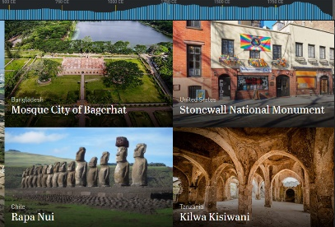  CyArk are a non-profit organisation who record and share the most significant cultural heritage sites. Find recordings and virtual tours of famous sites including Mount Rushmore National Memorial, Ancient Corinth in Greece, Brandenburg Gate in Germany, Tower of London in England and Rosslyn Chapel in Scotland to name a few.
Eiffel Tower |   Take a virtual tour of the Eiffel Tower, the tallest structure in Paris.  Here you can see a 360º panoramic view of Paris from the Eiffel Tower.
Giant’s Causeway |   Explore the rugged landscape around the Giant’s Causeway in Northern Ireland.
Great Wall of China |   This Virtual Tour of the Great Wall of China is beautiful and makes history come to life.    Airpano provides a virtual journey of the Great Wall of China (as well as many other places around the world) through photos and videos.
Machu Picchu |   Take a virtual tour of Peru’s 15th century Incan citadel: Machu Picchu, one of the New Seven Wonders of the World and a UNESCO World Heritage Site.
Neuschwanstein Castle |   Visit Neuschwanstein Castle, Germany’s fairy tale castle. The fairy tale look of the castle is rumoured to be Walt Disney’s inspiration for the castle in the Disney classic, Cinderella. It is also the inspiration for Sleeping Beauty’s castle in Disneyland.  You can also have a look inside each room of the castle.
New Orleans |   Go on a completely immersive and interactive tour of New Orleans. Ride in a streetcar down St. Charles Avenue. Visit Cafe du Monde and Commander's Palace or take a plantation or swamp tour. Stroll through the Convention Center or some of the major hotels.
Petra in Jordan |   Petra in Jordan is an ancient city and World Heritage Site with jaw-dropping architecture and amazing views. Watch these live streams to see the spectacular site.
Palace of Versailles |   A virtual tour of the Palace of Versailles in France including stories, artwork, rooms and gardens.  Tour the city of Versaille, starting at the palace.
Pyramids of Egypt |   Take a virtual tour of the world-famous Pyramids of Egypt. You can even see the Sphinx and inside the Mastaba Tombs.
Roman baths | 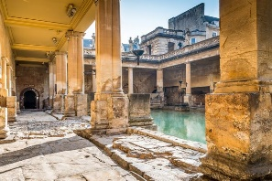  Take a virtual walk through the iconic Roman baths, in Bath, England. Explore the Great Bath, heated rooms, plunge pools and the terrace. You can even take a virtual tour of some of the museum exhibitions.
Royal Residences Tours | 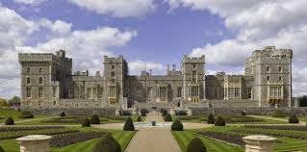  Explore some of the rooms of Buckingham Palace: an iconic building and official residence of The Queen; the Queen's official residence in Scotland, the Palace of Holyroodhouse; or Windsor Castle: a royal home and fortress for over 900 years.
Shakespeare’s Globe Theatre | 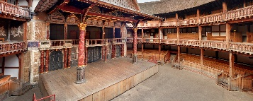  Shakespeare’s Globe Theatre can be enjoyed with an interactive 360º virtual tour, with photos, videos and audible wonder to guide you.
Son Doong Cave | 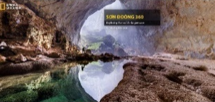  Explore the world’s largest cave: Son Doong Cave in Vietnam.
Stonehenge | 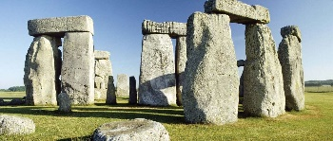  Take an interactive tour of Stonehenge with 360º views from inside the monument. Select the hotspots to find out more.
Taj Mahal |   Stroll along the iconic gardens of the Taj Mahal in India or view some great aerial shots of the monument and the surrounding city of Agra.
Yellowstone National Park |   Mud Volcano, Mammoth Hot Springs, and so much more. Tour Yellowstone National Park!
History Museums
Anne Frank’s House | 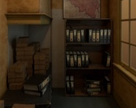  Take a look around and discover the secret annex where Anne Frank hid for more than 2 years during WWII and where she wrote her diary.
Boston Children’s Museum |   Walk through the Boston Children’s Museum for 3 floors of fun, thanks to Google Maps!
British Museum, London | 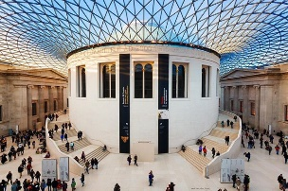  British Museum London: While there’s no walkthrough experience, the Rosetta Stone and Egyptian mummies are just a couple of things that you're able to see on a virtual tour of the museum.
National Museum of Anthropology | 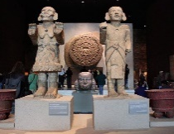  Visit the National Museum of Anthropology in Mexico City and dive into the pre-Hispanic history of Mexico with 23 exhibit rooms full of Mayan artefacts.
Natural History Museum | 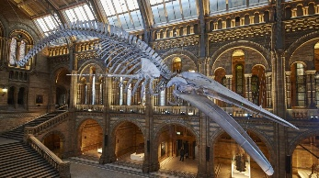  At the Natural History Museum in London, find answers to your big nature questions and uncover the history of life on Earth, from the smallest insects to the largest mammals.
Smithsonian National Museum of Natural History | 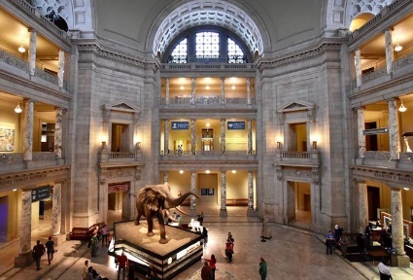  Take a room-by-room tour of select exhibits and areas within the Smithsonian National Museum of Natural History, including past and current exhibits. This virtual tour also features a handy map, so you can move between floors easily and select the exhibits you specifically want to see.
The Vatican Museums and City |   The Sistine Chapel, St. Peter's Basilica and Raphael's Room, are just some of the sites you can see on the Vatican's virtual tour of their 7 museums.  Here’s a 360º experience of Vatican City itself, including St. Peter’s Square.
Music and Film
Berlin Philharmonic: Digital Concert Hall |   Berlin Philharmonic: Digital Concert Hall  The great conductors and soloists of our time  Hundreds of concerts covering six decades  Free interviews and concert introductions  Exciting documentaries and artist portraits  Free Education Programme concerts for the whole family
The Kennedy Center | 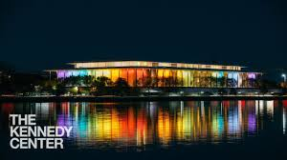  Watch extraordinary performances, covering a range of music and dance genres, from the Kennedy Center's digital stage.  Children can also create Lunch Doodles with Mo Willems; explore 30 different resource collections on topics such as Africa, Ancient Civilisations, Innovators, Inventors & Explorers, Science, Space and World Arts and Culture; or explore media and interactive tools on over 100 themes from African Drumming to Swing Dance.
Science Centres
Liberty Science Center, New Jersey |   Welcome to LSC in the House, the place where home scientists can conduct experiments, explore the world of LSC’s animals, find amazing movies to watch, and get inspired about science and technology without ever leaving the living room.
Science Museum, London |   Ignite your curiosity with a virtual walkthrough of London’s Science Museum. You can also search their entire collection.
Space and Planets
Aurora Borealis |   View the Northern Lights, natures most amazing light show, from Churchill Northern Studies Center in Manitoba, Canada. The live camera allows you to scroll backwards to see the previous nights show, each day.
Mars | 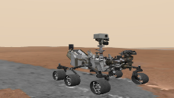  Explore the surface of Mars on the Curiosity Rover.
Nine Planets: The Solar System | 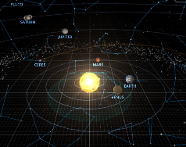  Take a virtual tour to explore our solar system, the night sky and outer space in real-time.
NASA |   Take a 360-degree, virtual tour of the NASA Mission Operations Room, home to the Hubble Space Telescope.  Alternatively, why not let your creativity take flight at NASA STEM with engineering activities, online games and even videos to get you moving and training like an astronaut?
Smithsonian’s National Air and Space Museum |   The Smithsonian's National Air and Space Museum maintains the world's largest collection of aviation and space artefacts, encompassing all aspects of human flight, as well as related works of art and archival materials. Here, you can take a virtual tour of the museum.
U.S. Space and Rocket Museum, Huntsville |   See the Saturn 5 Rocket on YouTube and more on this tour thanks to a real father/son outing.
Zoos and Animal Cameras
Atlanta Zoo |   Atlanta Zoo have set up a Panda Cam.  They also have a little selection of learning at home resources.
Cincinnati Zoo and Botanical Garden |   Check in at 8p.m. (due to the time zone difference) for a daily Home Safari on the Cincinnati Zoo and Botanical Garden’s Facebook Live Feed. A different animal will feature each day and the zoo keepers will set a simple follow up activity, too.
Duke Farms | 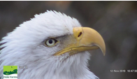  Duke Farms installed a webcam on a tree adjacent to a Bald Eagle nest to provide a live look at the daily lives of the eagles.
Explore | 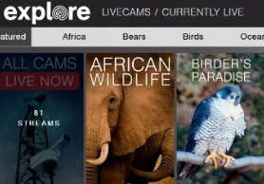  Explore have numerous live cams from all around the world, organised into easy to navigate themes and categories.  They also have some free lesson plans and activities linked to their more popular nature cameras.
Houston Zoo |   Houston Zoo has 6 Animal Cams including giraffes, gorillas, elephants, leafcutter ants, rhinos and chimps. The elephants are often very playful!
Kansas City Zoo |   4 animal cams at Kansas City Zoo: king penguin, gentoo penguin, polar bear and Masai giraffe
San Diego Zoo - kids |   The San Diego Zoo has a website just for kids with amazing videos, activities, and games. Enjoy the tour!  This zoo probably has the most live cams available: pandas, baboons, penguins, polar bears, apes, koalas, giraffes, burrowing owls, elephants, tigers and condors.
Wolf Conservation Center |   This collection of webcams allow you to enter the private lives of "Ambassador" wolves Atka, Alawa, Zephyr and Nikai, and seven elusive packs of critically endangered wolves via unobtrusive cameras in and around den sites.
FarmFood 360 |   This Canadian site, FarmFood 360, offers 11 Virtual Tours of farms from minks, pigs, and cows, to apples and eggs.
Discovery Education Virtual Trips |   This website has several virtual trip options covering a range of topics. A few of the topics include Polar Bears and the Tundra, Social Emotional Skills, STEM and Manufacturing. Each virtual trip comes with a companion guide, too.

