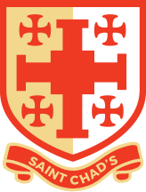

Information for Parents
Year 1 Phonics Screening Check
Alien Words
(Nonsense Words)
The alien words will be shown to your child with a picture of an alien. This provides the children with a context for the alien word which is independent from any existing vocabulary they may have. ‘Alien’ words are included because they will be new to all pupils; they do not favour children with a good vocabulary knowledge or visual memory of words.
Reporting to Parents
By the end of the summer term all schools must report each child’s results to their parents. They will also confirm if the child has met the standard threshold. Children who do not achieve the expected level will retake the test when they are in Year 2.
How Can I Help My Child at Home?
~ Read as much as possible to and with your child.
~ Encourage and praise – get them to have a ‘good guess’.
~ If your child is struggling to decode a word, help them by encouraging them to say each sound in the word from left to right.
~ Blend the sounds by pointing to each one, e.g. /ng/ in sing, /ee/ in been.
What is the Phonics Screening Check?

Children in Year 1 throughout the country will all be taking part in a phonics screening check during the same week in June. Children in Year 2 will also take the check if they did not achieve the required result when in Year 1. The phonics screening check is designed to confirm whether individual children have learnt phonic decoding and blending skills to an appropriate standard.

What Happens During the Screening?

The test contains 40 words. Each child will sit one to one and read each word aloud to a teacher. The test will take approximately 10 minutes per child, although all children are different and will complete the check at their own pace. The list of words the children read is a combination of 20 real words and 20 alien words (nonsense words).
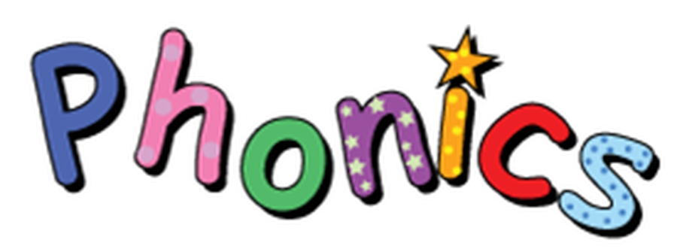
What is Phonics?

Children begin to learn phonics (sounds) in the EYFS. Once children begin learning sounds, these sounds are used orally to identify and make words. They will then begin to learn the letters which make each of the sounds and these are used to read and spell words. For this reason, the first initial sounds that are taught are ‘s’, ‘a’, ‘t’, ‘p’, ‘i’, ‘n’. These can immediately be blended for reading to make simple CVC words e.g. sat, pin. Children then develop segmenting for writing skills; breaking the word into sounds to spell it out.

