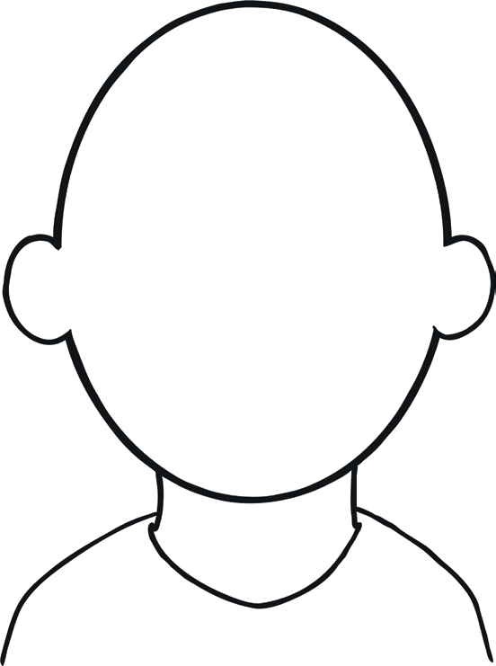
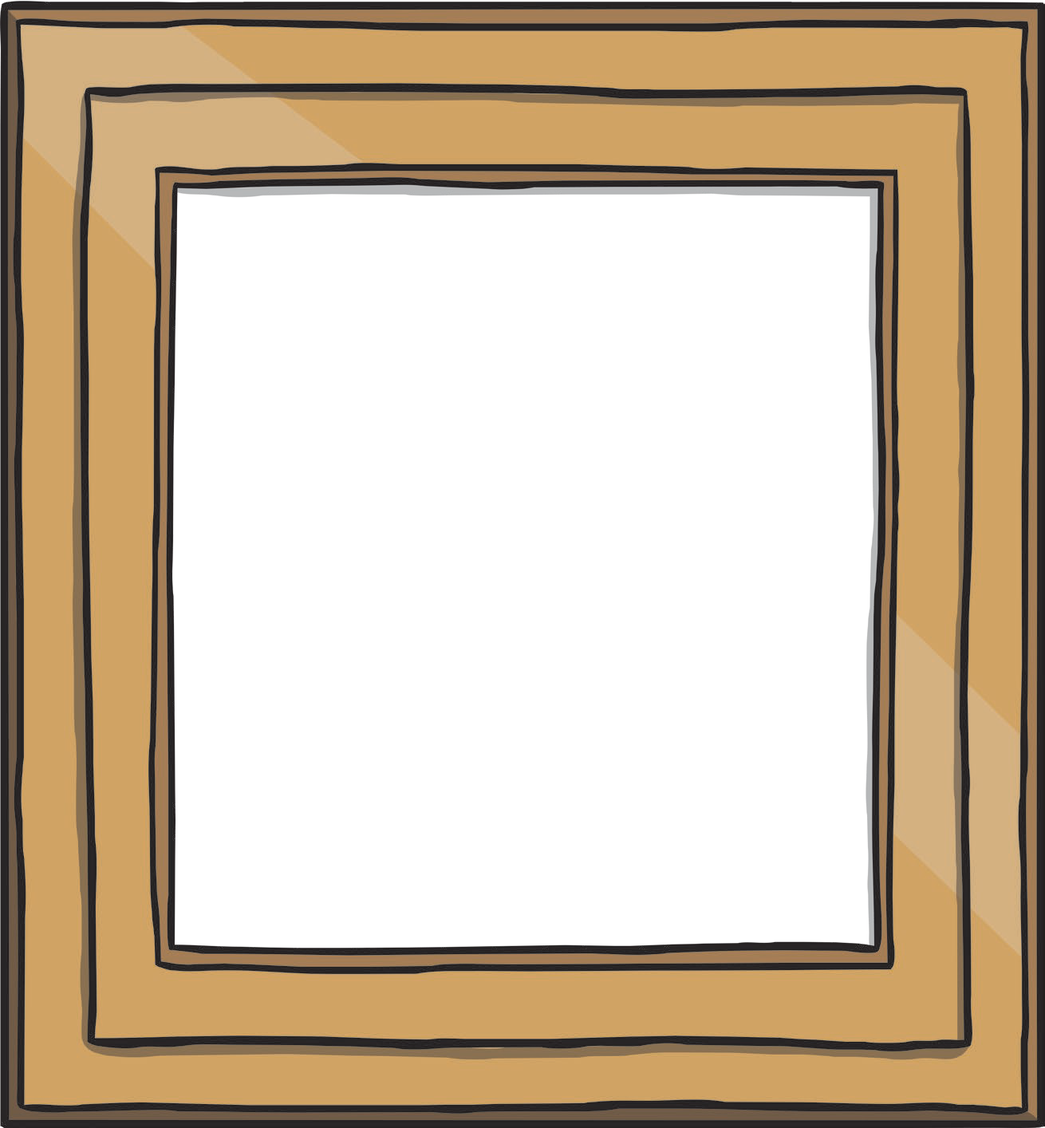

This Is Me
My hair:
What makes me, me:
My eyes:

This Is You
Your hair:
What makes you, you:
Your eyes:

