BACKGROUND NOTES FOR PARENTS AND CARERS

About the Theme – The Sacrament of Reconciliation

To help us understand this Sacrament we need to know a little bit about a Sacrament.
A sacrament is something that uses signs – usually a combination of words and actions, that have a message for those who are celebrating it; they give them a gift. This gift (which Catholics call grace) is given by Jesus whom they meet in the Sacrament, to strengthen their relationship with him. Through the Sacraments God helps Catholics grow in friendship with him.

The Sacrament of Reconciliation is known by various names:
- The Sacrament of Confession: This emphasises the confession of sins to a priest.
- The Sacrament of Forgiveness: This emphasises the belief that through the priest’s prayer of absolution God grants the forgiveness of sin.
- The Sacrament of Conversion: This emphasises the call to return to the Father from whom one has strayed through sin.
- The Sacrament of Reconciliation: This emphasis that through the Sacrament the penitent is reconciled to God, and to each other.
- The Sacrament of Penance: This is the official title given to the sacrament and emphasises the need for the penitent to do penance to repair any damage their sins may have done.

In the Sacrament of Reconciliation the key signs are:
- The words of absolution which removes a person’s sins.
- The laying on of hands which occurs many times during the sacraments to symbolise the giving of strength and power. When the sign is used in the Sacrament of Reconciliation, it reminds us of the times when Jesus laid his hands on the sick and healed them.
Through these signs Jesus heals the person of sin and reunites them with God and God’s family – the Church.

This Sacrament was given by Jesus after the resurrection when he said to his apostles ‘Whose sins you forgive they are forgiven; for those whose sins you retain they are retained’. It was through these words that Jesus gave his Church the power to forgive sin and to reconcile sinners.
The Sacrament of Reconciliation brings those who receive it back to God, who forgives them and absolves them from their sins. During the Sacrament of Reconciliation the Church celebrates the gentle love and mercy of God which is illustrated in parables such as The Lost Sheep and The Prodigal Son. The Sacrament calls people to confess sins, seek forgiveness and be reconciled to God and to one another. It is a celebration because while Catholics are sorry for their sins, they know that, no matter how badly their friendship with God has been damaged, God still loves and heals the sinner.

For Catholics the Sacrament of Reconciliation is a source of joy and comfort. In the Sacrament they experience time and time again the extraordinary love of God.
CELEBRATION OF THE SACRAMENT OF RECONCILIATION

Catholics prepare for the sacrament by thinking about what to say to the priest. They may pray to the Holy Spirit to give them strength, guidance and courage to make a sincere and honest confession. Then Catholics make an examination of conscience. Your conscience is the sense of right and wrong that is inside you, and helps you to make good choices. During an examination of conscience the penitent (the person receiving the sacrament) thinks about what they have done and the bad choices for which they are sorry. The bad choices which are done on purpose are sins – that is something that spoils or breaks friendship with God and with other people. Sin is anything that breaks God’s law of love.

The Sacrament
The priest welcomes the penitent and greets him or her with kindness in the name of Jesus. They make the Sign of the Cross together. The priest invites the penitent to have trust in God. He may say ‘May God, who has enlightened every heart, help you to know your sins and trust in his mercy’.
The priest might then read a short scripture passage which reminds the penitent of the mercy and gentleness of God who loves us and is always ready to forgive us.
The penitent confesses his/her sins – the bad choices they identified during the examination of conscience.
After the confession the priest may give a few words of advice and encouragement and then gives a penance which may be a prayer or a practical act of kindness. This is to give the penitent the opportunity to show the sincerity of their sorrow so that they may, in some small way, repair the damage his/her sins have done.
After a penance is given and accepted, the penitent expresses his/her sorrow. The person prays an act of sorrow, such as:
“O my God, because you are so good, I am very sorry that I have sinned against you
and with the help of your grace I will not sin again.”
This is one of the most important parts of the Sacrament. If the Sacrament of Reconciliation is to have an effect there must be true sorrow. To be truly sorry involves a determination to avoid repeating the wrong. It is not enough to say sorry – the penitent has to be willing to change and promise to make a new start. This is called making a firm purpose of amendment.
The priest then administers the Sacrament of Reconciliation. To do this he either places his hands on the penitent’s head or extends his right hand over the penitent’s head. The priest then prays the prayer of absolution which is the blessing that removes the person’s sins. The priest makes a Sign of the Cross over the penitent as he recites the final words of the Prayer of Absolution, “And I absolve you from all your sins in the name of the Father, and of the Son, and of the Holy Spirit.” It is enough for the children to know that the sign of the cross reminds us how Jesus loved us so much he died for us. It reminds us of God’s love and forgiveness.
The penitent replies “Amen” to this prayer. The Sacrament ends with a very short prayer of thanks and dismissal which reminds the penitent of the great joy and comfort the Sacrament brings.

Key Vocabulary | YEAR 4  Building Bridges  RECONCILIATION  In order for bridges to be built, a person has to acknowledge wrongdoing, so as to be reconciled to others and to God. This can be formally celebrated in the Sacrament of Reconciliation.  Children know and understand:  • Building bridges of friendship  • The importance of admitting wrong and being reconciled with God and one another  See Background Notes for Parents and Carers  Lesson 2: Read the story of the Lost Sheep and discuss the meaning of ‘sin’. Read the Greatest Commandment and talk about what it means to ‘examine our consciences’. Ask children to write a short story/account about the ways in which God’s law of love can be broken and how a bridge might be rebuilt.
bridges
friendship
contrition
Absolution
Sacrament of Reconciliation
Examination of Conscience
sin
penance
confession
Overview

Year 4
Year 4 children learn about the importance of building bridges in our relationships with others and with God; what sin is; the significance of an examination of conscience, contrition and absolution; and the Sacrament of Reconciliation.
Lesson 2: Read the story of the Lost Sheep (see below) and answer the questions.
People get lost when they deliberately do something wrong, hurting others, themselves or the world they live in. That is what is called ‘sin’. It is also anything you choose to do or not to do that spoils or breaks your friendship with God and with other people. Read The Greatest Commandment (see below).
Christians try to build bridges towards one another every day. They ‘examine their consciences’ to see how they have kept these two commandments. Our conscience is like a voice or feeling inside us. This is the Holy Spirit helping us to respond to God. It is good to think every evening, before you go to bed, about how you have built bridges of love and friendship or, perhaps, broken them through sin. We remember if we have done something that hurt someone else or if someone else has hurt us. We can thank God for all the good and say sorry for the bad and know that God, like the good shepherd, cares about us and loves us. We also must try to forgive those who have hurt us.
When we have made wrong choices the Sacrament of Reconciliation brings us back to God, who forgives us and absolves us from our sins. God’s mercy and love is like the tenderness shown in the story of the Lost Sheep. We can be sure God loves us.
Think about the ways in which God’s law of love can be broken. Write a short story/account to illustrate one of these occasions and how a bridge might be rebuilt.
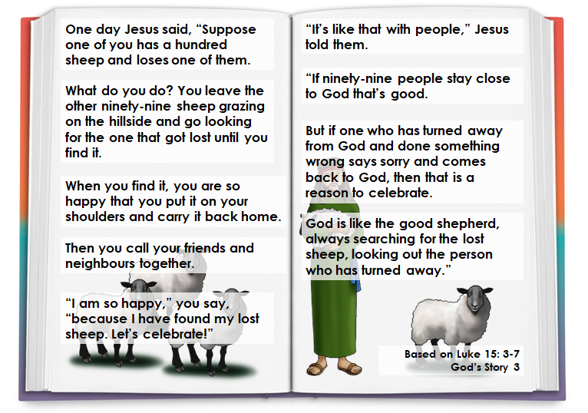
Lesson 2 - The Lost Sheep

- What did the story of the ‘lost sheep’ mean to you?
- Did it surprise you that the shepherd would go to find the one lost sheep?
- When are the times you might see yourself as the lost sheep?
- What does this story tell you about God?
The Greatest Commandment
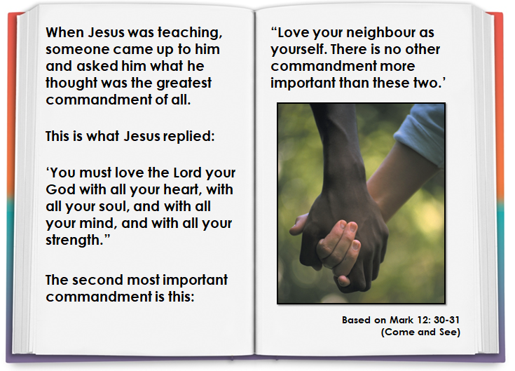
- Which is easier – to love God or to love your neighbour? Is there a difference?
- Why do you think love of God and love of our neighbour is so important?
- What would be another commandment?

