BACKGROUND NOTES FOR PARENTS AND CARERS

About the Theme – The Sacrament of Reconciliation

To help us understand this Sacrament we need to know a little bit about a Sacrament.
A sacrament is something that uses signs – usually a combination of words and actions, that have a message for those who are celebrating it; they give them a gift. This gift (which Catholics call grace) is given by Jesus whom they meet in the Sacrament, to strengthen their relationship with him. Through the Sacraments God helps Catholics grow in friendship with him.

The Sacrament of Reconciliation is known by various names:
- The Sacrament of Confession: This emphasises the confession of sins to a priest.
- The Sacrament of Forgiveness: This emphasises the belief that through the priest’s prayer of absolution God grants the forgiveness of sin.
- The Sacrament of Conversion: This emphasises the call to return to the Father from whom one has strayed through sin.
- The Sacrament of Reconciliation: This emphasis that through the Sacrament the penitent is reconciled to God, and to each other.
- The Sacrament of Penance: This is the official title given to the sacrament and emphasises the need for the penitent to do penance to repair any damage their sins may have done.

In the Sacrament of Reconciliation the key signs are:
- The words of absolution which removes a person’s sins.
- The laying on of hands which occurs many times during the sacraments to symbolise the giving of strength and power. When the sign is used in the Sacrament of Reconciliation, it reminds us of the times when Jesus laid his hands on the sick and healed them.
Through these signs Jesus heals the person of sin and reunites them with God and God’s family – the Church.

This Sacrament was given by Jesus after the resurrection when he said to his apostles ‘Whose sins you forgive they are forgiven; for those whose sins you retain they are retained’. It was through these words that Jesus gave his Church the power to forgive sin and to reconcile sinners.
The Sacrament of Reconciliation brings those who receive it back to God, who forgives them and absolves them from their sins. During the Sacrament of Reconciliation the Church celebrates the gentle love and mercy of God which is illustrated in parables such as The Lost Sheep and The Prodigal Son. The Sacrament calls people to confess sins, seek forgiveness and be reconciled to God and to one another. It is a celebration because while Catholics are sorry for their sins, they know that, no matter how badly their friendship with God has been damaged, God still loves and heals the sinner.

For Catholics the Sacrament of Reconciliation is a source of joy and comfort. In the Sacrament they experience time and time again the extraordinary love of God.
CELEBRATION OF THE SACRAMENT OF RECONCILIATION

Catholics prepare for the sacrament by thinking about what to say to the priest. They may pray to the Holy Spirit to give them strength, guidance and courage to make a sincere and honest confession. Then Catholics make an examination of conscience. Your conscience is the sense of right and wrong that is inside you, and helps you to make good choices. During an examination of conscience the penitent (the person receiving the sacrament) thinks about what they have done and the bad choices for which they are sorry. The bad choices which are done on purpose are sins – that is something that spoils or breaks friendship with God and with other people. Sin is anything that breaks God’s law of love.

The Sacrament
The priest welcomes the penitent and greets him or her with kindness in the name of Jesus. They make the Sign of the Cross together. The priest invites the penitent to have trust in God. He may say ‘May God, who has enlightened every heart, help you to know your sins and trust in his mercy’.
The priest might then read a short scripture passage which reminds the penitent of the mercy and gentleness of God who loves us and is always ready to forgive us.
The penitent confesses his/her sins – the bad choices they identified during the examination of conscience.
After the confession the priest may give a few words of advice and encouragement and then gives a penance which may be a prayer or a practical act of kindness. This is to give the penitent the opportunity to show the sincerity of their sorrow so that they may, in some small way, repair the damage his/her sins have done.
After a penance is given and accepted, the penitent expresses his/her sorrow. The person prays an act of sorrow, such as:
“O my God, because you are so good, I am very sorry that I have sinned against you
and with the help of your grace I will not sin again.”
This is one of the most important parts of the Sacrament. If the Sacrament of Reconciliation is to have an effect there must be true sorrow. To be truly sorry involves a determination to avoid repeating the wrong. It is not enough to say sorry – the penitent has to be willing to change and promise to make a new start. This is called making a firm purpose of amendment.
The priest then administers the Sacrament of Reconciliation. To do this he either places his hands on the penitent’s head or extends his right hand over the penitent’s head. The priest then prays the prayer of absolution which is the blessing that removes the person’s sins. The priest makes a Sign of the Cross over the penitent as he recites the final words of the Prayer of Absolution, “And I absolve you from all your sins in the name of the Father, and of the Son, and of the Holy Spirit.” It is enough for the children to know that the sign of the cross reminds us how Jesus loved us so much he died for us. It reminds us of God’s love and forgiveness.
The penitent replies “Amen” to this prayer. The Sacrament ends with a very short prayer of thanks and dismissal which reminds the penitent of the great joy and comfort the Sacrament brings.

Key Vocabulary | YEAR 4  Building Bridges  RECONCILIATION  In order for bridges to be built, a person has to acknowledge wrongdoing, so as to be reconciled to others and to God. This can be formally celebrated in the Sacrament of Reconciliation.  Children know and understand:  • Building bridges of friendship  • The importance of admitting wrong and being reconciled with God and one another  See Background Notes for Parents and Carers  Lesson 3: Explore what happens in the Sacrament of Reconciliation, reading from Church’s Story 3. Look at what contrition and absolution mean. Ask children to make a glossary of all the new words they have learnt about the Sacrament of Reconciliation.
bridges
friendship
contrition
Absolution
Sacrament of Reconciliation
Examination of Conscience
sin
penance
confession
Overview

Year 4
Year 4 children learn about the importance of building bridges in our relationships with others and with God; what sin is; the significance of an examination of conscience, contrition and absolution; and the Sacrament of Reconciliation.
Lesson 3: Read ‘The Sacrament of Reconciliation’ from Church’s Story 3 (see below). This Sacrament has been given to us to confess or acknowledge our sins, seek forgiveness and be reconciled to God and one another. Those receiving this sacrament may be sure of the love and mercy of God.
The most important thing that people preparing to receive the Sacrament of Reconciliation need is to be sorry for their sins. There is a special word for this – ‘contrition’. When you have had a quarrel with someone, you can never make up unless you are really and truly sorry – that is, if you have contrition. It about realising the consequences of what you have done, the hurt you have caused to others, as well as to yourself.
There are two different ways of celebrating the Sacrament of Reconciliation, individually visiting the priest or within a Service of Reconciliation
At the end of the Sacrament of Reconciliation the priest says the words of absolution. The priest gives the person a penance to fulfil. Sometimes it is a prayer to say or sometimes the priest might ask the person to do something extra. When we do something wrong and then later feel sorry about it, we want to make up for it in some way. Then, after the person prays an Act of Sorrow, the priest raises his hands as a sign of God’s love and says the words of forgiveness and absolution. He asks God to forgive and absolve the person from their sins. To be absolved of sin means to be free from sin. This is what the priest says:
I absolve you from your sins in the name of the Father, and of the Son and of the Holy Spirit.
This sacrament is a special way to experience God’s love and peace. The person usually stays in church or in a quiet place to say their penance, if it is a prayer. They will thank God for this opportunity to experience his love and forgiveness and promise to try to do better.
Make a glossary of all the new words you have learnt about the Sacrament of Reconciliation in a grid (see below)

Lesson3: The Sacrament of Reconciliation (Church’s Story 3)
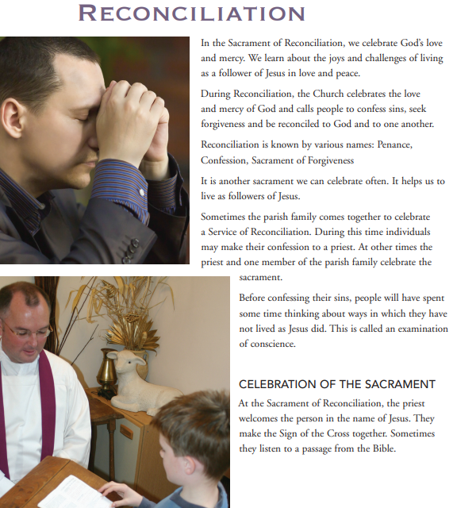
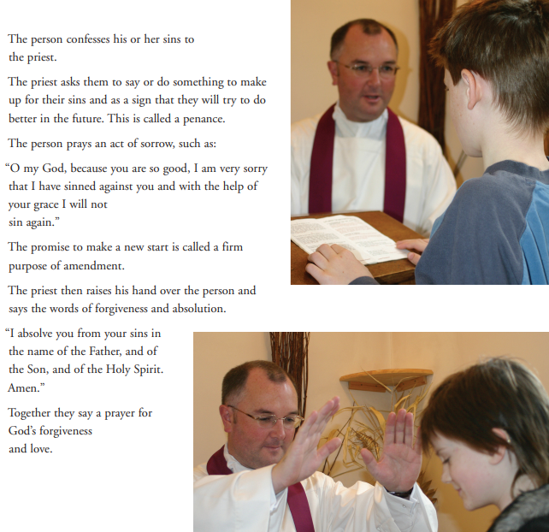
Lesson 3: What do these words mean?
Word | Meaning
Reconciliation

Sin

Examination of conscience

Contrition

Penance

Absolution

