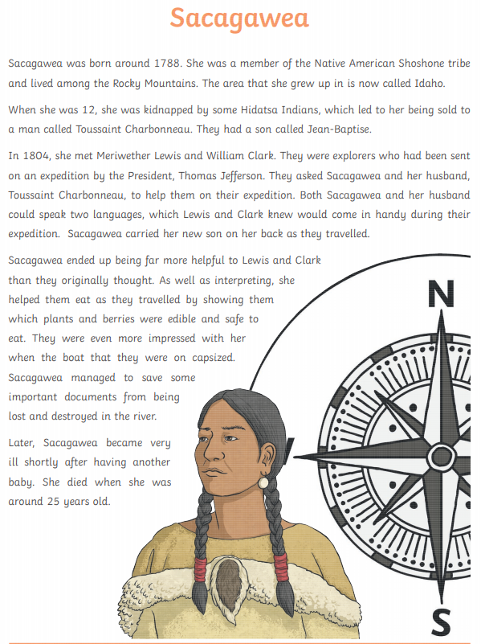

When was Sacagawea born?
_____________________________________
Which tribe did she belong to?
_____________________________________
Where did she live?
_____________________________________
What happened to Sacagawea at age 12?
_____________________________________
_____________________________________
What did Lewis and Clark ask Sacagawea to do in 1804?
_____________________________________
Why was Sacagawea so helpful?
_____________________________________
_____________________________________
Why do you think Sacagawea is still honoured and remembered to this day?
_____________________________________
_____________________________________
_____________________________________

