12th November 2020

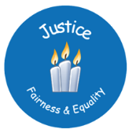

Dear Parent/Carers

This half terms Gospel Value focus is on Justice. We will be focusing on the area of Social Justice, teaching the children what it means and how they can support the view that everyone deserves equal economic, political and social rights and opportunities. As a school, we will be focusing specifically on Common Good and Creation and the Environment.
As part of our focus we will be holding a very exciting, ‘Zero Hero’ day on Wednesday 25th November, to introduce to the children, the idea that we want to be heroes of good and heroes for the environment. We are asking all the children to come to school that day, dressed as a superhero. You do not need to go out and buy a costume for the day, your son/daughter will simply require a cape and perhaps some home-made wrist bands or a headband. As the focus is on encouraging zero emissions in the environment, it would be good if they could draw/paint the letter Z onto any part of their costume. Ideally, we do not want commercial superhero costumes, like Superman and Spiderman, but you may want to adapt a costume that you already own. The children will be making superhero face masks in school that week to go with their costume. There is no charge for wearing their costumes.
In class the children will be partaking in lots of activities, that teach them about how we need to respect God’s creation and share it fairly with all people around the world, particularly the poor and vulnerable.
Kind regards
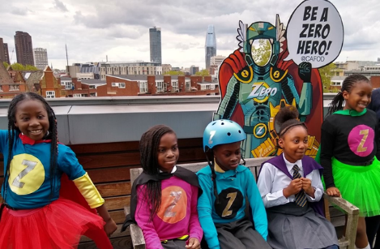
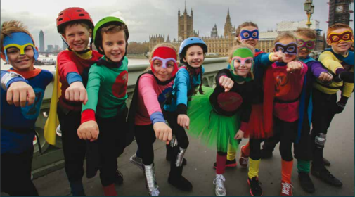

Mrs Mitchener

