
Year Six Team
St. Therese of Lisieux: Mrs Mitchener
St Brigid: Mrs Mooney
TA’s Mrs Bowler & Mrs Streek
Homework:
Mon | Tues | Wed | Thur | Fri
English | Reading | Maths | Spelling | Reading
P E: St Brigid - Monday / St Therese – Thursday

Computing

Children will learn how to use search technologies effectively, appreciate how results are selected and to be discerning with digital output, as well as researching Antarctica and the Arctic. It is expected that the children will present the Polar regions using Power Points. We will create our own digital scrapbooks, selecting and using a variety of software, including the internet for research. We will create and deliver multimedia presentations, selecting, analysing, editing and presenting chosen data and relevant information

MFL
The children will study basic French vocabulary and culture.
Autumn 1 2024-2025
Year 6 Frozen Kingdom
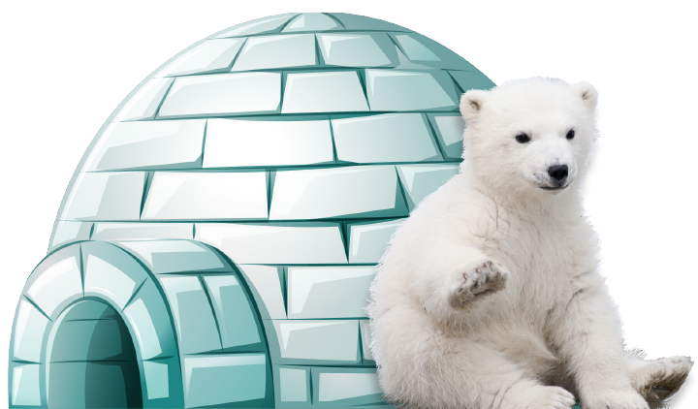

Religious Education
Loving: The Domestic Church
In this unit the children will celebrate and respond to the love and care of people around them and learn that God’s love is unconditional and never ending. They will learn that forgiveness is an essential part of unconditional love. Children will also reflect on their own families and how they show unconditional love and forgiveness.
RSE
The children will be focusing on the wonder of God’s love. They will cover the emotional, social and spiritual aspects of this topic.
PSHE:
Me and My Relationships. The focus will be on being a good citizen, including Global citizenship.

Humanities
Geography: We will be looking at maps and globes to locate the Artic and Antarctica as well as identifying the equator and tropical belt, using appropriate geographical vocabulary. As climate change is a growing concern for the planet, we will recognise how people can improve the environment or damage it and the impact it has. We will identify and explain the significance of the Polar Regions, researching similarities and differences between their climates.
History: We will be looking at the history and development of polar exploration and will follow the journey of significant people to develop a chronological narrative, making links between key civilisations, events and inventions. We will use the web and other resources to find information and images to study an aspect in British history.

Science
Living things and their habitats
We will learn how an animal is adapted to its environment, focusing on animals in the Polar Regions. We will draw links with our science learning inheritance and evolution, understanding how certain species (humans, animals and plants) adapt for survival in their habitats

DT: We will be using cardboard boxes to construct a large-scale igloo.

PSHE: Getting on and Falling out
Children will focus the value of diversity and cooperation and continue to build a positive classroom ethos.

Mathematics: Number and Place Value
During this topic we will read, write and order numbers to 10, 000, 000. We will also round whole numbers and learn about negative numbers in context of temperature.
Calculations: The children will secure their use of written methods for all four operations.
There is a need to have a secure rapid recall of multiplication and division facts.

Understanding the Expressive Arts
Art /DT: We will research the artwork of the Inuit (the Arctic’s indigenous people) such as Inuit prints and carvings of birds, sea mammals, polar bears and wolves. We will use the work of significant printmakers to influence our own Inuit artwork. Using the media of photography, we will create our own art inspired by or giving an environmental message. Having observed the phenomenon on the Northern Lights, we will paint our own detailed landscapes including perspective.
Music: We will have opportunity to improvise and create our own music using a range of timbres, textures, rhythms and motifs. We will compose a piece of music based on the Frozen Kingdom topic using percussion

Understanding English, Communication & Languages

Through our integrated approach to English, we will be using Shackleton’s Journey as our driver text and will create diaries, letters, newspaper reports and poems.
We will continue to deepen our understanding of levels of formality through reporting on the sinking of the Titanic and recounting the journey of Scott across Antarctica. We will develop use of specialist technical vocabulary within our explanations, ensuring clear purpose and consideration of our audience. We will use the polar context as a setting for narrative writing, we will learn, perform and create our own poems, and give interviews in character as part of our polar rescue mission. Within all this, we continue to develop the accuracy and variety of our sentence styles and use of wider punctuation.

.

