
Religious Education
During RE this half term, we will continue to follow the Come and See Scheme and our topics will be Promises and Visitors. The children will be becoming more aware about the lead up to the birth of Jesus and the importance that this holds for us.
RSE
The children will be focusing on how God loves us in our differences. They will cover the emotional, social and spiritual aspects of this topic.
PSHE:
Valuing Difference. The focus will be on understanding that we live in a world where everyone is different but still important.

Autumn 1 2024-2025
Year 3: Across the Ages
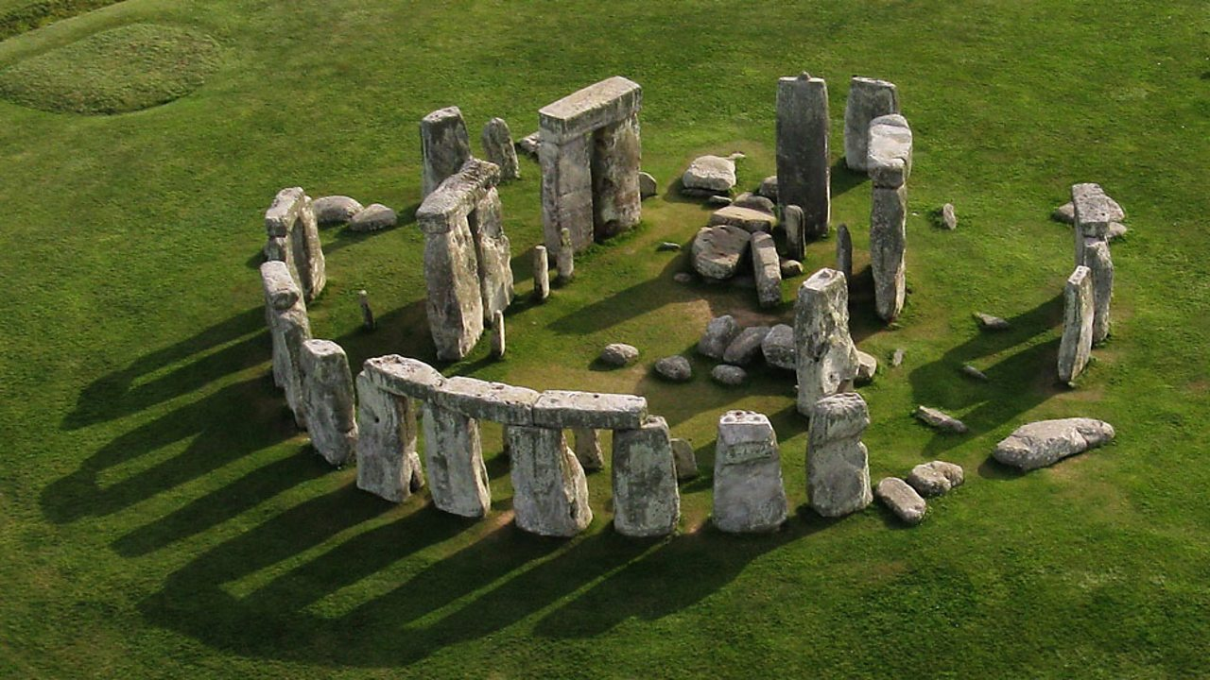

Mathematics: Addition and Subtraction and Multiplication and Division
The children will be looking focusing on the topics of addition and subtraction and beginning to further their understanding of multiplication and division this half term. We will be using the written method for addition and subtraction and also developing our ability to cross the regroup and exchange. Within our learning of multiplication and division, the children will be focussing on their 2, 3, 4, 5, 8 and 10 x tables.
Children will be tested weekly on their knowledge of multiplications and are strongly advised to practice daily.

Understanding English, Communication & Languages

Our four weekly will have a focus on the book ‘The Iron Man’ by Ted Hughes. This will develop both written and comprehension skills, around study of character and setting description, as well as producing writing outcomes, such as diary and letter writing. They will be broadening their emotive language vocabulary and using this within some longer pieces of writing. Through daily guided reading sessions, we will be practising comprehension skills, including inference and expression of reading aloud. Alongside development of literacy and comprehension skills, we continue to develop the accuracy and variety of our sentence styles and use of wider punctuation through weekly Grammar lessons.

We encourage children to borrow books from the classrooms and library to take home.

.

PE
This half term, we will be continuing to work on our ball skills and developing our throwing and catching skills. We will be introducing this into invasion games.

Mon | Tues | Wed | Thurs | Friday
 | St John Bosco | St Carlos | St Carlos | St John Bosco

Understanding the Expressive Arts
Art: We will be focusing on the skill of painting, specifically linking to our topic ‘Across the Ages’ by focusing on Cave paintings. We will then focus on sculpture and aim to recreate Stonehenge, using a variety of materials.
Music: Children will continue to develop their understanding of musical notations and learn to compose, play and perform both solo and music assembles. Children will also develop their vocal performance, practising accuracy, control and expression.

Year 3/4 Team

St. John Bosco: Miss McNicholas
St Carlos: Mr Moonsam
TA’s: Mrs Zajac & Mrs Koffi (1:1)
Homework: Reading records checked weekly. Please read with your child for at least 10 minutes every day.
Mon | Tues | Wed | Thurs | Fri
English given out  Maths due in | Spelling and Rainbow test |  | Maths given out  English due in

Mon | Tues | Wed | Thur | Fri
Comp | Maths | Grammar | Spelling  Reading | Maths

Humanities
History: Stone Age to Iron Age: We will be looking at how people lived across the Stone, Bronze and Iron Ages, focusing on key vocabulary during these time periods. We will develop key historical skills, such as understanding changes over time and chronology, studying sources and comparing time periods. We will look at how archaeologists and scientists worked together using evidence to draw conclusions about Cheddar Man and Skara Brae.

Science
Animals including humans:
This half term, we will be looking at our topic of animals including humans. We will be focusing on the skeleton and the functions it has. The children will learn about carnivores, herbivores and omnivores and the different food humans and animals need to help them grow.

Computing

The children will continue to work on their coding skills from last term. We will then move on to look at touch typing and exploring computer simulations.

MFL
The children will be furthering their French knowledge by learning 10 different animals. We will be developing our speaking, listening, reading and writing skills in French.

