Religious Education
I wonder, who am I?
Within the topic ‘Ourselves’ we will be reflecting on our own experiences of family, what the word ‘family’ means to us and the joys and sorrows of family life. We will also work on knowing ourselves as individuals and appreciating our own value and uniqueness. We will then deepen our understanding of who we are by recognising that God has made each of us special in our own unique ways. We will end our topic by relating this to our responsibility for stewardship of the earth.
Mathematics
We will begin this half term with our place value topic. We will be learning how to represent, partition, compare, order and round 1s, 10s, 100s, 1,000s, 10,000s and 100,000s. We will also spend time looking at negative numbers and how to represent numbers as Roman Numerals. We will then move on to addition and subtraction. Here we will learn how to add and subtract with and without an exchange using written methods. We will also learn how to estimate answers, use checking strategies, use inverse operations and round to approximate answers.
Literacy
I wonder, will Grendel be defeated?
This half term we will be reading Monster Slayer by Brian Patten which is a retelling of the legend Beowulf. This is a story about the monster Grendel who appears from ‘the fens and foul-smelling marshland beyond the forest’ and must be defeated by a young warrior named Beowulf.
Based on this text we will engage in a
number of different writing tasks
including; character descriptions,
kennings, play script, diary entries and
persuasive writing.

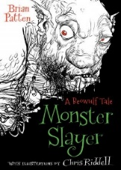

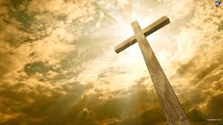
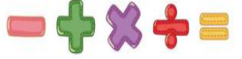
PE/Games
Both classes are taking part in a 10 day intensive swimming course at Thornton Heath Leisure Centre. Please ensure your child has their swimming kit each day for the following days:
St Andrew: 18th – 29th September
St James: 2nd – 13th October
Both classes will also be having their outdoor PE session with Coach Terry every Friday where they will be developing their understanding of attacking and defending in netball. Please ensure your child is wearing their correct full PE kit on these days.
PHSE
This half term our topic is ‘me and my relationships’ where we will be looking at feelings, friendship skills, cooperation and how to recognise emotional needs.
We will consider questions such
as ‘how good a friend are you’
and take part in a collaboration
challenge to learn all about give
and take.
INVASION
Year 5 (Autumn 1)

Mrs Bolshaw (St. Andrew) Mrs Chandler and Mrs Gallagher (St. James) and Mrs Tachie-Mens (TA)
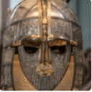
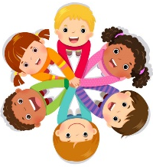
/
Music
Using the song ‘Jerusalem' we will be looking at changes through time. The children will have opportunities to compose and perform music inspired by their local community, both past and present.
Computing
The children will be developing their understanding of computer systems and how information is transferred between systems and devices.
Modern Foreign Languages
For our first French topic ‘les fruits’ the children will learn 10 fruits and be introduced to the simple opinions ‘I like’ and ‘I do not like’. By the end of the topic, they will have the knowledge and skills to be able to say which fruits they like and do not like.
Art and Design
We will be taking a close look at a range of intricate Anglo-Saxon pattern work and using this to inspire our own drawings use print blocks. While we are learning about different Viking gods and goddesses, we will build up a sketchbook of drawings of deities in various styles and poses.
Design and Technology
Design and make their own shields, considering what special features may be needed to fend off attackers. After investigating Anglo-Saxon recipes we will be making our own breads and honey shortbread biscuits.

Homework will be given every Friday and must be handed in by the following Wednesday. Please make sure your child reads daily at home and brings their signed reading record to school each day.
History
I wonder, who were the invaders and why did they settle in Britain?
We will be learning all about life in Britain after the Roman withdrawal, focussing specifically on the Anglo-Saxon and Viking invasions up to the Norman Conquest. We will learn about Anglo-Saxon and Viking life including; settlements and kingdoms, village life, art and culture.
Geography
We will spend time analysing invasion maps to help us identify where the invaders came from, where they settled and why. We will also explore the direction of each invading group and some of the physical and human features they would have encountered.
Science
I wonder, how useful are forces?
In our ‘forces’ topic, the children will be learning how forces affect everything around us. They will learn about the effects of gravity, friction, air and water resistance as well as carrying out a number of different investigations and fair tests to answer their own scientific questions.

