RE
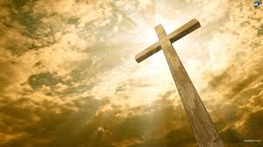

This term we will be spending some time looking at Judaism. Children will learn about what happened at Passover and look at how it is still celebrated. Our Advent and Christmas topic it titled Hope.
Understanding English, Communication & Languages
English
Children will be reading and writing descriptions of real and imaginary settings, based on the topic. They will also be writing information texts about two planets after significant researching. A biography on either Galileo or Copernicus will also be written alongside an explanation about what each of these scientists discovered.

Computing: We will be developing an understanding of search engines and how to search safely for information on the internet.
MFL: This term we will be learning how to count in Spanish as well as practising simple greetings. We will also learn how to answer and ask questions relating to age.

Scientific, Health and Technological Understanding
Science: Children will learn about the eight planets in our Solar System. They will know that our Sun is a star and why life on earth depends on it. They will also learn why we have day and night. Phases of the moon and the four seasons is also something that will be explained.
PSHE: Children will recognise their own and others strengths and how they can develop perseverance. This will also reflect our RE topic, whereby children celebrate the gifts God has given them.
DT: Children will design and make a model of space.

Mathematics
Children will start by interpreting and extracting information from charts and tables. They will move onto looking at square numbers and formal multiplication methods. They will need to recall and use our multiplication tables efficiently. We will end our term by focusing on problems relating to perimeter and area.

STARGAZERS
AUTUMN 2
YEAR 5
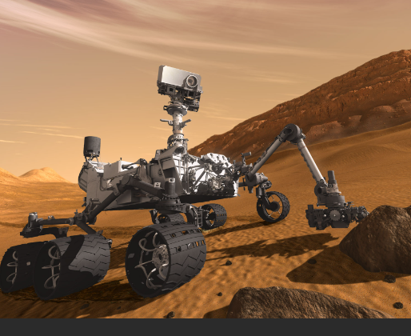

Homework given on FRIDAY and needs to be on the following WEDNESDAY PE Kits needed on Tuesday (St James), Wednesday (St Andrew) and Friday (both classes)

Understanding the Expressive Arts
Art: Children will recreate images taken by the International Space Station using basic classroom resources. They will also draw a scale drawing of the Solar System and a 3D model of their chosen planet.
Music: The Planet Suite. (Gustav Holst)
PE/ Games: . PE Kits needed on Tuesday (St James), Wednesday (St Andrew) and Friday (both classes)

Historical, Geographical and Social Understanding
History:
Children will look at the life of Galileo and appreciate how his findings impacted key religious beliefs in the sixteenth and seventeenth century. They will also appreciate the historical context of the moon landings.
Geography: Children will look at the different landscapes on planet Earth using images from the ISS. They will describe key geographical features.

Class teachers:
ST JAMES: Mrs Chandler and Mrs Gallagher
ST ANDREW: Mrs Bolshaw

