
Understanding English, Communication & Languages

Our four weekly literacy lessons will link to our topic subject ‘Across the Ages’. To start with, we will be focusing on the book ‘Into the Forest’ and gaining confidence and stamina with our written work. We will then be reading the book ‘UG, Boy Genius of the Stone Age’. This will develop both written and comprehension skills, around study of character and setting description, as well as producing writing outcomes, such as diary and letter writing. Through daily guided reading sessions, we will be practising comprehension skills, including inference and expression of reading aloud. We will also be focusing on a class book, which we will be reading daily. Alongside development of literacy and comprehension skills, we continue to develop the accuracy and variety of our sentence styles and use of wider punctuation through weekly Grammar lessons.

We encourage children to borrow books from the classrooms and library to take home.

.

PE
This half term, we will be practising skills associated with cricket, including catching, bowling and batting, as well as team building games to develop team and leadership skills.
Mon | Tues | Wed | Thurs | Friday
 | St John Bosco | St Carlos | St Carlos | St John Bosco

Science
Rocks, Fossils and Soils:
Linking to our Stone Age topic, children will learn how to compare and group together different kinds of rocks on the basis of simple physical properties. They will also to be about to describe in simple terms how fossils are formed and recognise that soils are made from rocks.

Understanding the Expressive Arts
Art: We will be focusing on the skill of painting, specifically linking to our topic ‘Across the Ages’ by focusing on Cave paintings. We will then focus on sculpture and aim to recreate Stonehenge, using a variety of materials.
Music: Children will continue to develop their understanding of musical notations and learn to compose, play and perform both solo and music assembles. Children will also develop their vocal performance, practising accuracy, control and expression.

Humanities
History: Stone Age to Iron Age: We will be looking at how people lived across the Stone, Bronze and Iron Ages, focusing on key vocabulary during these time periods. We will develop key historical skills, such as understanding changes over time and chronology, studying sources and comparing time periods. We will look at how archaeologists and scientists worked together using evidence to draw conclusions about Cheddar Man and Skara Brae.

Computing – Coding

Children will begin by understanding what a flowchart is and how they are used in computer programming. They will then begin to introduce the use of timers and other commands used within the coding programme. The children will finish the topic by learning how to design and create an interactive scene.

Year 3/4 Team

St. John Bosco: Miss McNicholas
St Carlos: Mr Moonsam
TA’s: Mrs Zajac & Mrs Koffi (1:1)
Homework: Reading records checked weekly. Please read with your child for at least 10 minutes every day.
Mon | Tues | Wed | Thurs | Fri
English given out  Maths due in | Spelling and Rainbow test |  | Maths given out  English due in

Mon | Tues | Wed | Thur | Fri
Comp | Maths | Grammar | Spelling  Reading | Maths

MFL
The children will study basic French vocabulary and culture.
Autumn 1 2024-2025
Year 3: Across the Ages
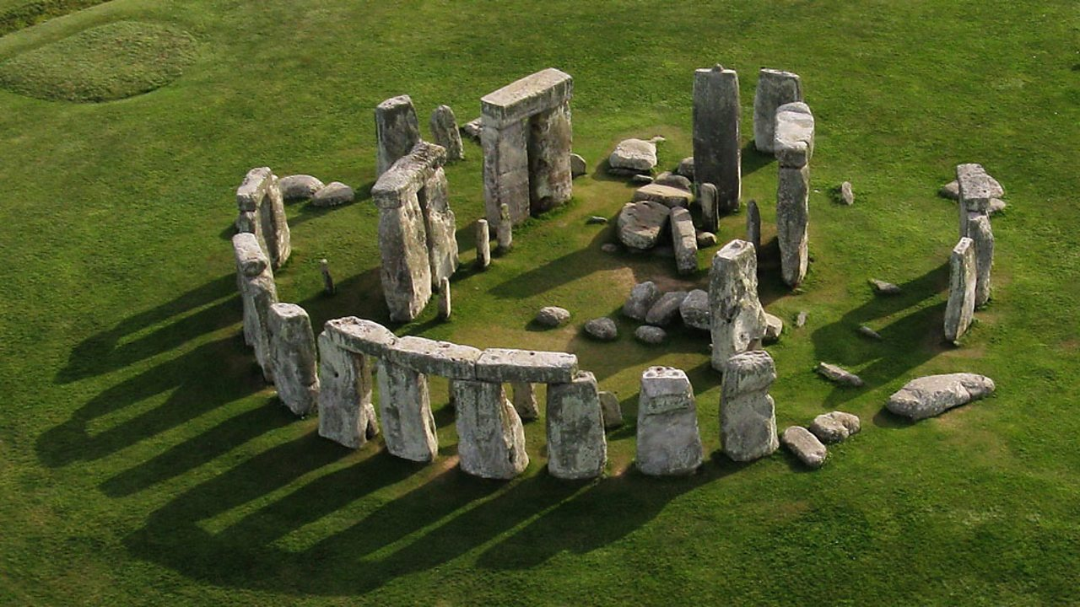

Religious Education
Loving: The Domestic Church
In this unit the children will celebrate and respond to the love and care of people around them and learn that God’s love is unconditional and never ending. They will learn that forgiveness is an essential part of unconditional love. Children will also reflect on their own families and how they show unconditional love and forgiveness. We will then be looking at the sacrament of Confirmation and Baptism.
RSE
The children will be focusing on how God loves us in our differences. They will cover the emotional, social and spiritual aspects of this topic.
PSHE:
Being me in My World. The focus will be on being a good citizen, including Global citizenship.

Mathematics: Number and Place Value
During this topic, we will focus on representing numbers to 1000, using a variety of formats and methods. We will also practise rounding whole numbers to the nearest tens, hundreds and thousands. Children will also develop their reasoning skills, using word problems.
Children will be tested weekly on their knowledge of multiplications and are strongly advised to practice daily.

