Sophie Sherman – Chair Odile (Dee) Ebanks – Deputy Chair
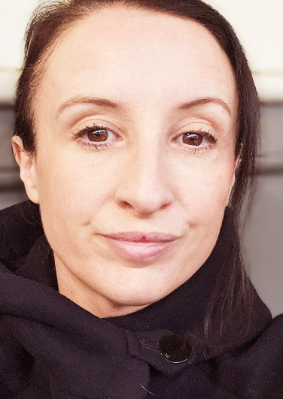


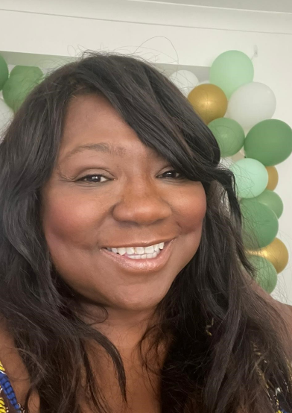
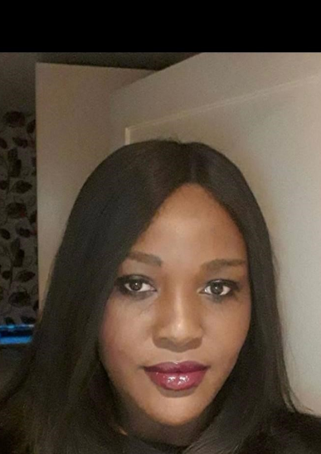
Augustine (Tina) Brobbey – Treasurer Deputy Treasurer


Stacy Harris - Secretary

