

The PTFA would like to encourage you to join Easy fundraising today to help raise funds for St. Chad's School, South Norwood whenever you shop online via:
http://www.easyfundraising.org.uk/causes/stchadscatholicschoolptfa

Please support this worthy cause to generate free donations from thousands of retailers. Don’t let us miss a free donation.

www.easyfundraising.org.uk



MY NAMETAGS Iron-on and Sticker Name Tags
https://www.mynametags.com/affiliate?id=70008

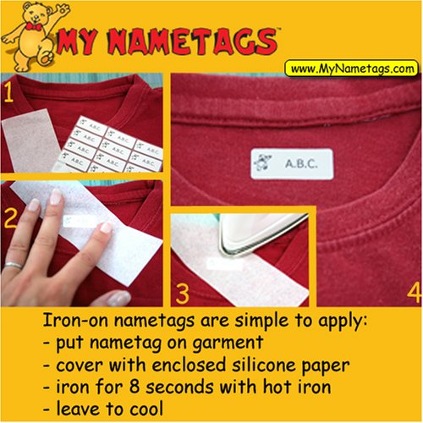

My Nametags (ID 70008)
Dear Parents, please order name tags through the link below. Please note that if you use the school name instead of the ID number when ordering online, the website will not recognise our school and so it will not be credited.
Let us know if you have any questions or need more information.
Kind regards
My Nametags
This link allows parents to click through and our school will automatically be credited with the order value.
<p>Go to My Nametags to <ahref="https://www.mynametags.com/affiliate?id=70008" title="Order page My Nametags">order nametags</a>, and help us raise funds</p>

WHICH NAMETAGS SHOULD I CHOOSE?
We believe there is a nametag out there for everyone! Deciding which type is perfect for you depends on where you would like to use them and how colourful you'd like them to be.
Our colour stickers are the most versatile as they are suitable for items, (stationery, books, pens etc) and clothing labels, and are available in a wide range of designs. If you want to attach the labels to fabrics however, it might be worth considering the colour or black and white iron-on nametags. And if you just want plain functional stickers suitable for hard surfaces, but not clothes, then the black and white stickers are for you.
For more information click here to see our range of name tags.

HOW DO I USE THE LABELS?
Our labels are simple to use, follow this link to see our handy guide.

DO YOU SHIP OVERSEAS?
Yes. We send labels all over the world on a daily basis.

CAN I SPLIT A SET OF LABELS?
We cannot split a set of labels to have more than one name. Due to the way the labels are produced it just isn't possible.

I NEED TO CORRECT A MISTAKE
Accidents do happen! If you have made a mistake when placing your order, or want to edit your delivery details, please get in touch with us within 10 minutes of placing the order and we'll be able to help.

MY ORDER HASN'T ARRIVED
Don't panic! We tell all customers to allow 10 WORKING days for deliveries. We use Royal Mail First Class post, while this will usually ensure your labels arrive the next day; it can be subject to postage delays out of our control. If your order still hasn't arrived after this time then contactsales@mynametags.com and we'll be able to help.

WHAT IF I'M NOT SATISFIED WITH MY NAMETAGS?
We pride ourselves on offering the best labels and customer service in the business, if you are unhappy with your labels, for whatever reason; please don't hesitate to get in touch with us sales@mynametags.com

